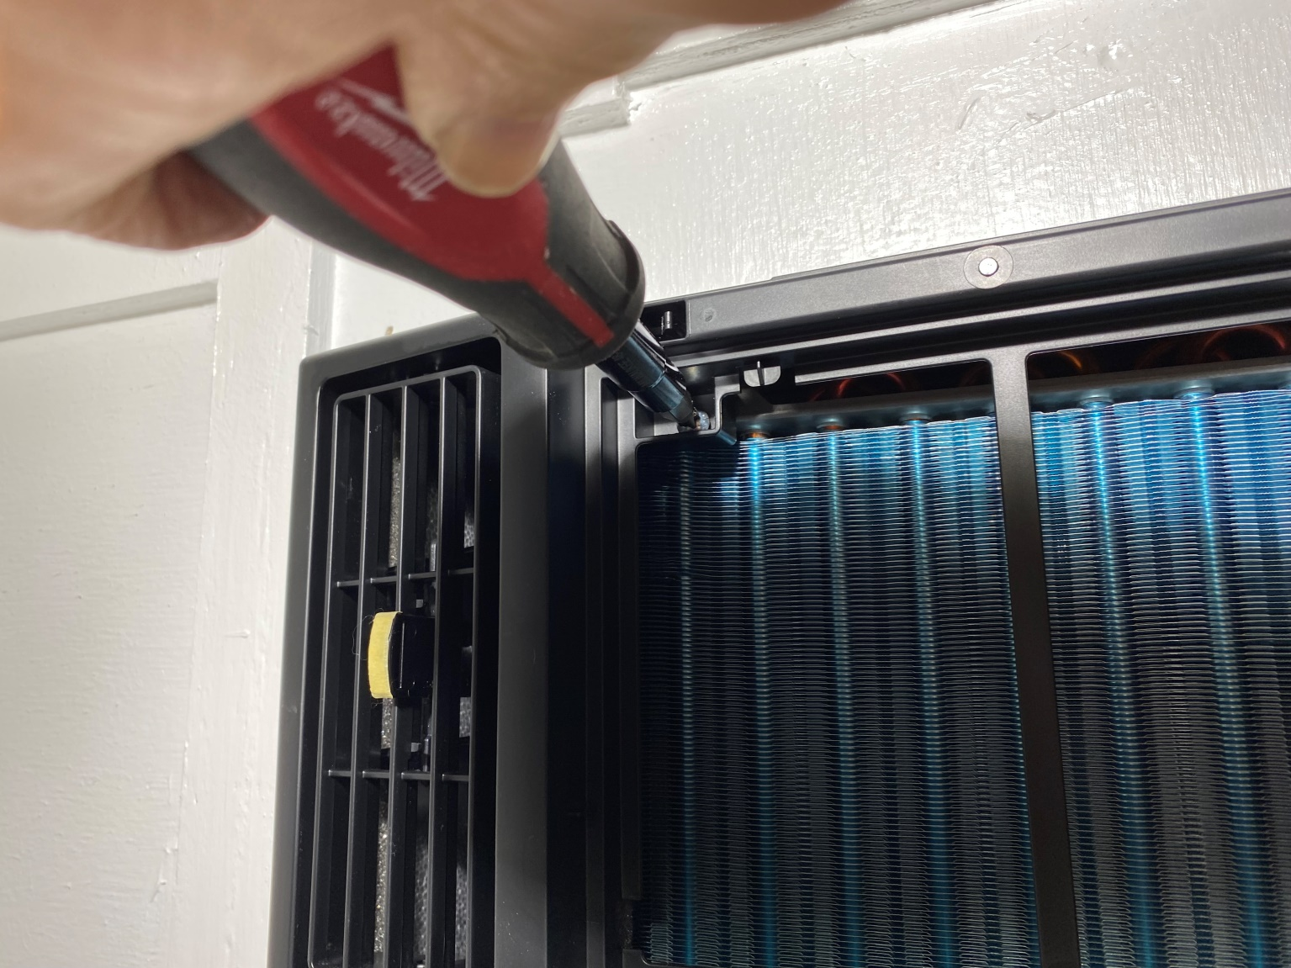
Right side, black cover screw, a second screw is located on the left side of the black cover
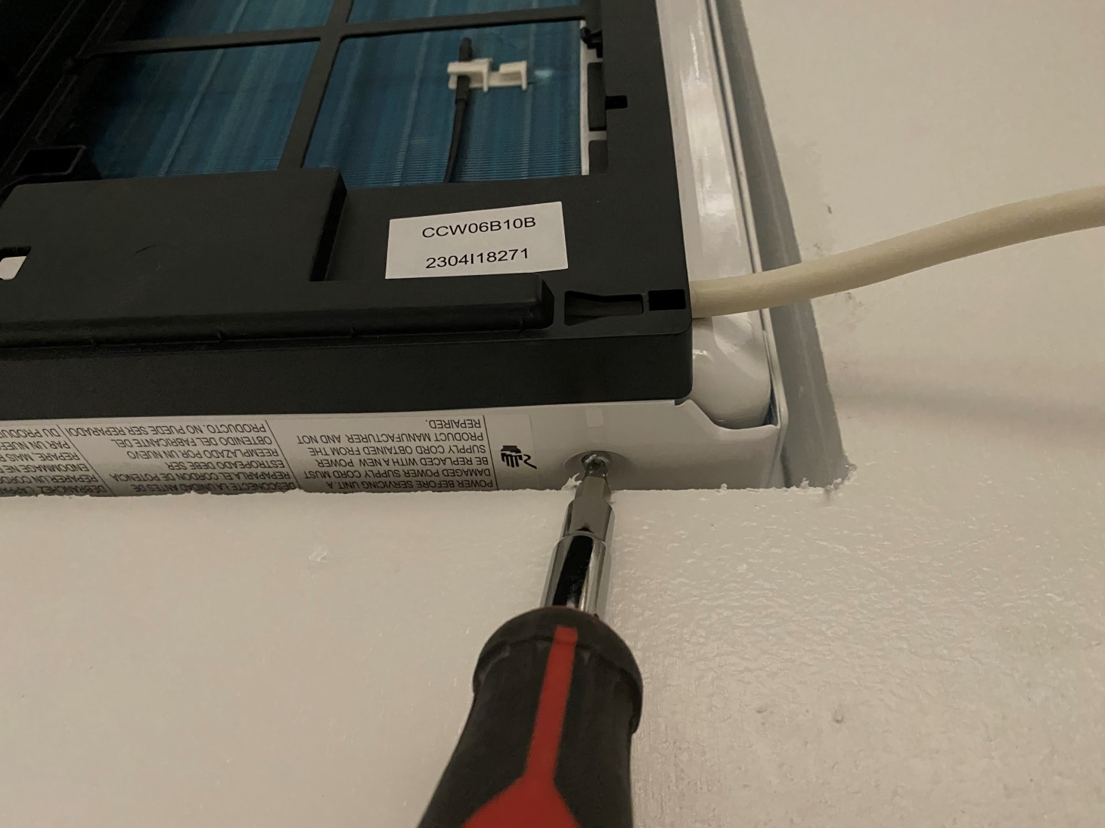
Side screw
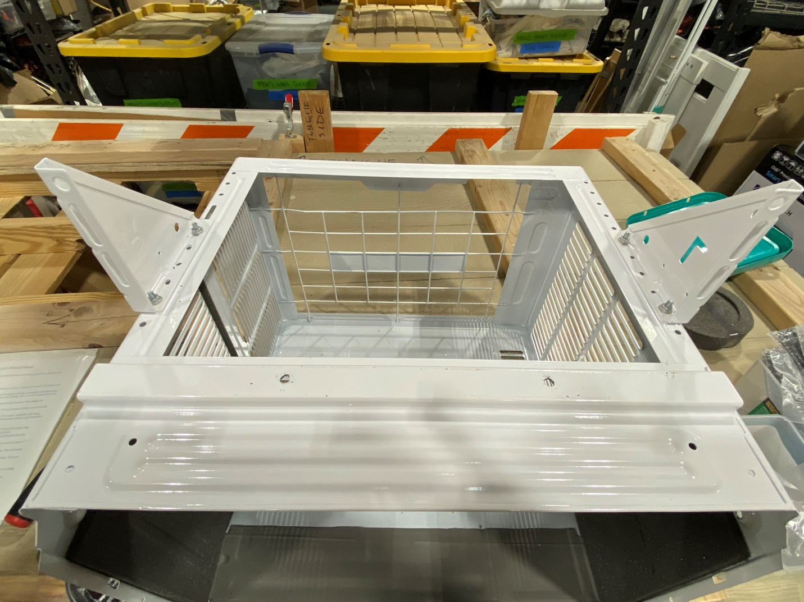
Bottom support brackets - right and left sides, note the hole alignment of the brackets and the two drilled holes in the bottom of the cover
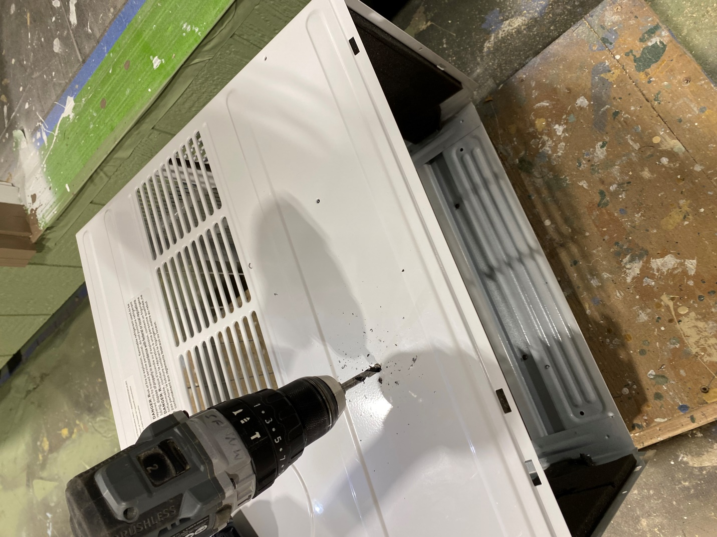
Top of the outer cover - using 3/16” drill bit, drill two holes through existing dimples in the top of the outer cover
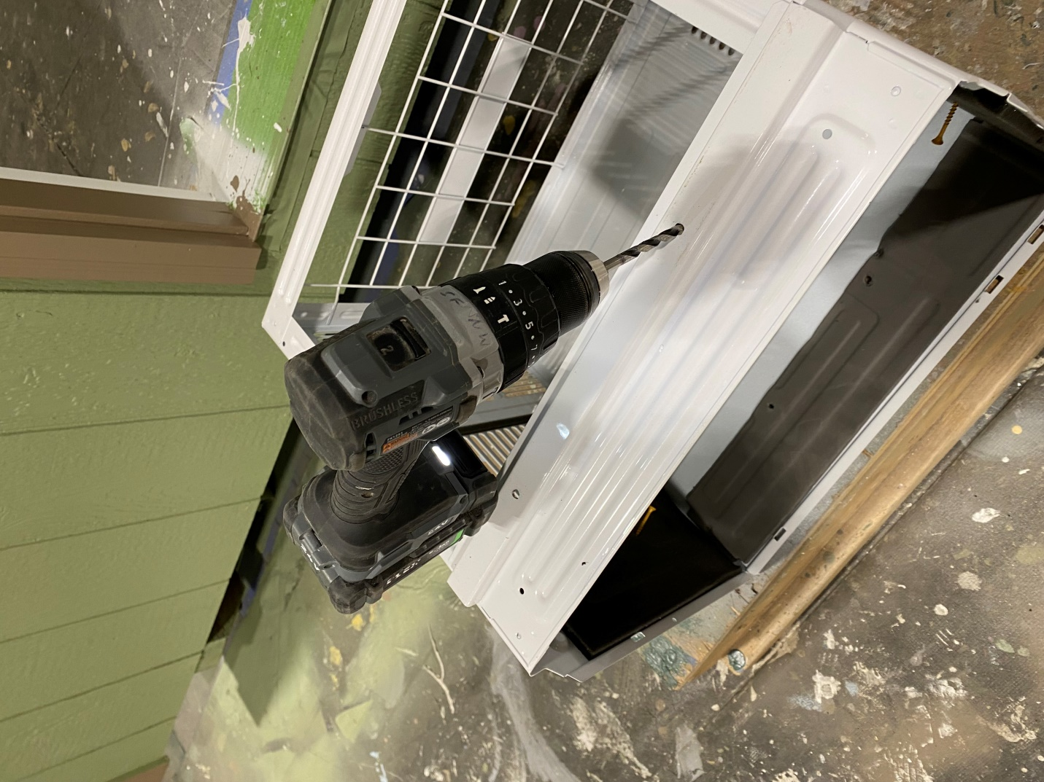
Bottom of the outer cover - using 3/16” drill bit, drill two holes through the bottom support rail in the outer cover
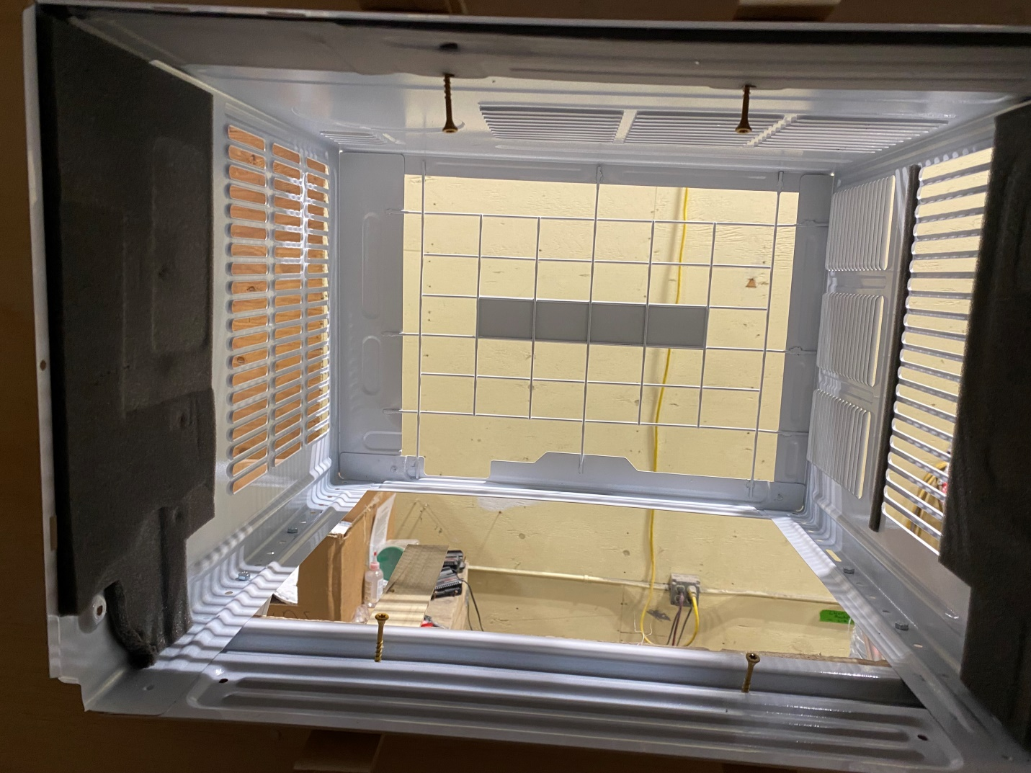
AC interior screws. Two short torx screws through the bottom support rail and two screws through the top of the box (through predrilled holes). Shim between the top of the box and the upper 2 by 4 framing for the two upper screws to keep from distorting the straight top on the box. The box must remain in its original rectangular shape for the black front cover to install correctly.

